(Approx. 704 words)

Gave Up My Mouse Long Ago and I’m Happy I Did
If You Hate Your Mouse, Try a Trackball Instead
By Kurt Jefferson, Editor, CKCS Newsletter
October 2022 Issue
https://ckcs.org/
lextown2 (at) gmail.com

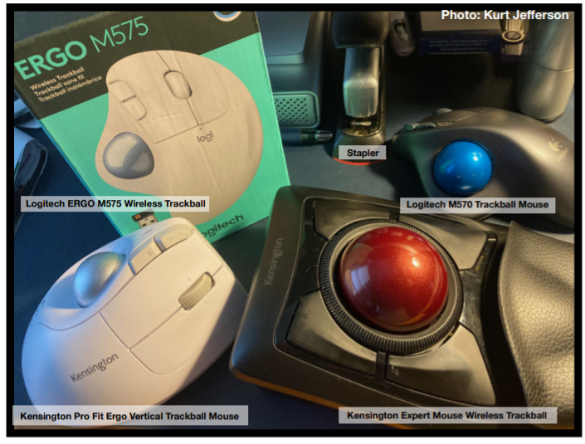
The article in Gizmodo doesn’t mince words with the headline: “With its big roly-poly ball and huge hand rest, the venerable trackball mouse looks like a holdover from 1996. Or maybe 1946 – that’s the first time a trackball was used as an input device in a computer,” writes Alex Cranz in his 2017 article.

He asserts the waning popularity of the lowly trackball after more of us began using the mouse and then the trackpad. Cranz adds, “But here’s the thing: The trackball is still good. Not just good—the trackball is great. So great that Logitech is introducing its first trackball in many years is a cause for celebration—even if I have some issues with my new favorite input device.”

So, in 2017, Switzerland–based Logitech introduced its first new trackball in years. Guess what? The MX Ergo was a major hit. And sales are still climbing. Last fall, Logitech reported a 26% increase in mice and trackball sales. (Logitech sells plenty of mice – but it’s also discovering many people insist on trackballs instead.)

Then, last October, Logitech introduced yet another trackball: the Ergo M575. The user can connect to a desktop or laptop, Mac or PC via a USB interface with a small transceiver or Bluetooth. It will also connect to an iPad using the Bluetooth option.

As more of us began working and teaching school from home in 2020 because of the pandemic, more of us are actively ditching our mice. (Plenty of us are still working and teaching from home via Zoom and other software.)

Make Tech Easier explains why trackballs are better for you: “More workers are aware of the health risks and problems associated with long periods of sitting daily. It’s supremely unhealthy, and many companies have made a serious effort to help modern office workers reduce the risks of desk-bound work.

While standing up will help your health, more ergonomic input devices can protect you from an RSI or repetitive strain injury.

These injuries are caused by repeatedly straining your body in the same way, over and over again. These injuries can cause numbness, tingling, and pain, and they won’t go away until you stop the stressor.

Trackball mice can be a blessing for workers suffering from a wrist-based RSI or carpal tunnel. The benefit comes from the trackball’s stable position. While you move your wrist and arm to manipulate a traditional mouse, you only need to move your fingers to use a trackball. If you use a wrist rest with your trackball, your wrist will be at a healthier angle. This frees it from the strain associated with sliding your mouse around. Because your hand stays in one place, your arm and wrist won’t be strained by the constant back and forth movement of a mouse.”

As Popular Mechanics wrote in June, “A trackball mouse is a great way to make endless mouse movement less strenuous.” It’s proven that trackballs reduce wrist stress and grip fatigue.

While the best–selling Logitech trackballs are thumb-operated, Kensington, which might be called the “king of trackballs,” sells at least seven trackballs on its website, on Amazon, Newegg, and other online sellers.

Because of growing demand, Kensington has released several new trackballs in recent years, including the:
- Expert Mouse Wireless Trackball
- Pro Fit® Ergo Vertical Wireless Trackball (White & Black)
- Orbit® Fusion Wireless Trackball
- Wired Orbit® Trackball with Scroll Ring
- Orbit® Optical Trackball.

The popular Expert Mouse Wireless Trackball often tops the ratings when reviewers put trackballs through their paces. The Wirecutter (a review website purchased by The New York Times), trackballmouse.org, gadgetreviews.com, and iMore all praise that finger-operated device.

A Japanese trackball maker, Elecom, has also earned a steady but growing market share in the States. Elecom currently makes the only trackball especially designed for left-handed users. It’s the Elecom M–XT4DRBK model. (Read about it here at amazon.com).

Popular Mechanic’s website tells what to look for as you decide whether or not to opt for the benefits of a trackball.

